Brandon O'linn and Santiago Lampon

IST 652 Final Project

Dr. Deborah Landowski

NFL: Passing and rushing comparisons

# Introduction:

How sports are played changes all the time and football is no exception. Football used to be a game dominated by prolific running backs with the quarterbacks more playing more like game managers. In the last several years that has drastically changed. Teams are throwing the ball now more than ever. Running backs are now more agile and have the same ability to catch the ball as most receivers. In fact it seems like if a running back can’t catch the ball there is not room for them in the NFL. Quarterbacks are no longer game managers but the most important and valued players in the game. Some quarterbacks used to have less than 20 passing attempts in a game, now some of them are throwing 40 to 50 times a game with Kansas City Chiefs quarterback Patrick Mahomes recently throwing 68 passing attempts in one game. The purpose of this analysis is to explore how the game of football has changed from 2019 to 2022 by looking at team data and individual player data.

# Datasets and how they were used:

Three datasets were used to explore the changes in how football is played the first is from NFL_data_py, the second is from web scraping NFL stats from Pro Football Reference, and the third is from a CSV provided by <https://www.advancedsportsanalytics.com/nfl-raw-data>.

nfl_data_py is a Python library for interacting with NFL data sourced from nflfastR, nfldata, dynastyprocess, and Draft Scout. Includes import functions for play-by-play data, weekly data, seasonal data, rosters, win totals, scoring lines, officials, draft picks, draft pick values, schedules, team descriptive info, combine results and id mappings across various sites. For this project, we used the nfl_data_py function to bring in nfl play-by_play data, roster data, and team description to later join the three tables into one. The data we have loaded has extremely rich play-by-play data taken from the NFL API.

We pulled quarterback stats from the 2019–20 NFL season from <https://www.pro-football-reference.com/years/2019/passing.html>

and use them to create radar charts to assess QB efficiency. To open the webpage and scrape the data, we will use two modules, urllib.request to open the URL, and BeautifulSoup to parse through the HTML. Note that we can easily adapt all this analysis to previous years by changing the 2019 in URL to the year of your choosing. The two BeautifulSoup functions we will use to scrape the page are findAll() and getText(), which return values based on the HTML of the page we are scraping. I present simplified use cases below — for all possibilities you should refer to the documentation.

The dataset from advanced sports analytics provided many variables, but ultimately some of them were not necessary so they were removed prior to being pulled into python. Then a column was added to reflect what year the game was played in. The dataset itself contained individual player stats on a per game basis for the 2019 season through half of the current 2022 season.

# Analysis:

## Exploratory analysis:

Exploratory analysis was done to see year to year stats of some of our favorite players. These players included Nick Chubb and Derrick Henry to of the NFLs best running backs. We looked to see if their rushing yards per game dropped over the years.

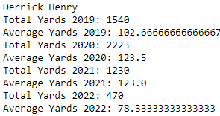

The results show that for both Chubb and Henry held steady or even increased their production from 2019-2022. Although halfway through the 2022 season Henry is off to a shaky start compared to recent years. Possibly due to teams scheming against him because his last three season were insane.

Next, we looked at Tom Brady and Patrick Mahomes Passing attempts.

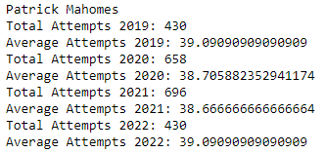

The results of this show that Brady increased from 38 attempts per game in 2019 to 42.5 per game so far in 2022. Mahomes who came into the league throwing a lot in the Texas Tech air raid offense has always had a lot of passing attempts but surprisingly his he hasn’t fluctuated much and has been consistently at 38 to 39 a game. He does however have some huge outliers with a 50 and 54 attempt game in 2021.

Now we look at one of the most balanced offensive attacks in the NFL the Green Bay Packers, they have a great quarter back and running back in Aaron Rodgers and Jones. To examine this team’s offense, we look at their total rushing attempts and passing attempts in each season.

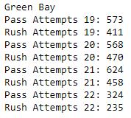

In 19 and 20 there were at a total of 573 and 568 passing plays and 411 and 470 rushing plays. Then in 2021 they threw on 624 plays and ran on 458. They are on pace again to throw the ball over 600 times and run the ball over 400 times. This tells us that although passing attempts are increasing it is not negatively impacting the number of rushing plays.

## Radar Graphs on Quarterback Efficiencies

ESPN's Total Quarterback Rating is a proprietary statistic that was introduced in 2011 and is designed to measure the total effectiveness and performance of a quarterback. The metric and considers all quarterback's contribution to a game, including passing, rushing, sacks, penalties, touchdowns, and turnovers. Moreover, each play is weighted based on its "difficulty", the context of the game, and the strength of the opposing defense. This means that statistics in garbage time of a blowout game hold less merit than statistics in a close game. Also, a quarterback who throws for four touchdowns and 300 yards against a strong defense will have a higher QBR than a quarterback who has the same stat line against the worst defense in the NFL.

We wanted to display into a radar graph all the attributes of the quarterbacks for the 2019 and 2020 season just to show the possibilities of data analytics in sports. The code will show the output of all the quarterbacks efficiency graphs for 2019 and 2020 seasons. Next, I will just show a few and talk about some comparisons between the two seasons for some quarterbacks.

2019 – NFC West

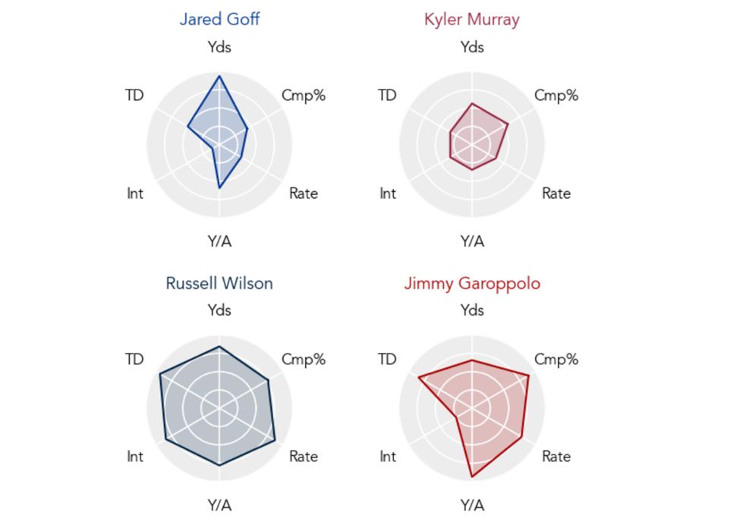

The NFC West is a division of the National Football League. Then I will explain what the different categories used in the radar graphs are.

TD = Total touchdowns thrown in the season

Yds = Total yards thrown in the season

Int = Total interceptions thrown in the season Note: this stat is inverted

Y/A = Yards per passing attempts

Rate = Quarterbacks rating at the end of the season

Cmp% = Completion percentage at the end of the season

Let’s compare Russell Wilson and Jimmy Garoppolo stats for 2019. You can see that Jimmy had a higher completion percentage than Russell but a higher interception count. Next, we will show stats from two different seasons and compare. Tom Brady 2019 and 2020 seasons

Tom Brady’s last season with the New England Patriots was full of controversy but ultimately, he just didn’t have enough offensive weapons to help him out in 2019. In 2020, he went to the Tampa Bay Buccaneers and helped them win the Super Bowl.

### Tom Brady 2019 New England Patriots: Eliminated in the playoffs

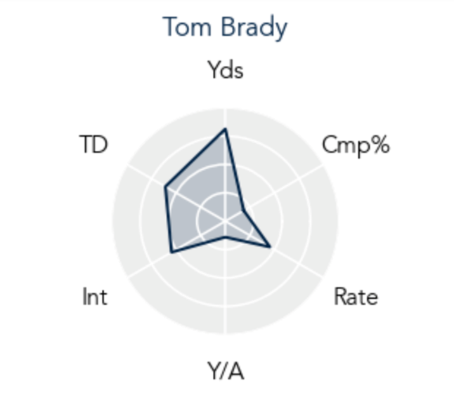

### Tom Brady 2020 Tampa Bay Buccaneers: Won the Super Bowl

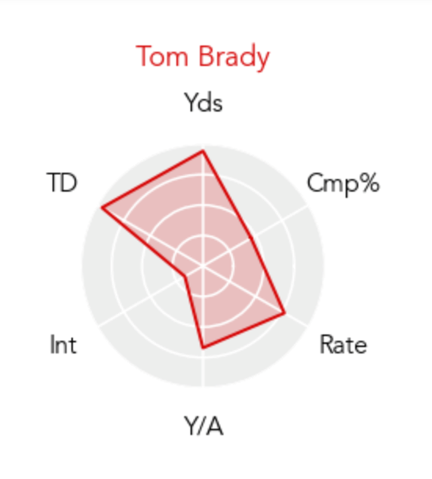

You can clearly see how he improved in every category, when you clearly have a better offense to work with. Lastly, we will look how the radar graph looks on one of the highest paid quarterbacks in the league, Aaron Rodgers.

Aaron Rodgers – 2020 Green Bay Packers

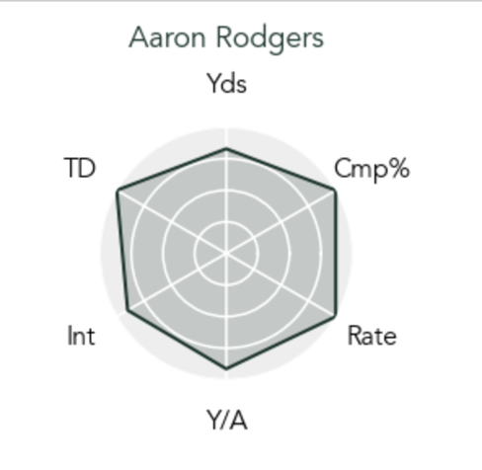

One could argue that looking at Aaron Rodgers radar efficiency graph that he could be one of the best-rounded quarterbacks in the league statistically speaking. There are many other factors that can affect the quarterback’s statistics per season, but this is still a great tool to use to tell many stories. Teams probably use this information to see if a quarterback is worth trading and paying for. Quarterbacks can use this information to see what they need to work on to get better at the game. The possibilities of data are endless.

## nfl_data_py

For this project, we used the nfl_data_py function to bring in nfl play-by_play data, roster data, and team description to later join the three tables into one. The data we have loaded has extremely rich play-by-play data taken from the NFL API. The NFL API provides users with access to a database of current and past NFL football statistics and game information. The database is updated every minute, even while games are being played. Data is available going back to 2009. We wanted to show a different way to access information using the API’s already available in python. Three tables were brought in and used a left and right join to link the three data sets into one.

The next graphs will show the production of the quarterbacks in the 2021 season. This graph is excluding the playoffs and 2-point conversions. We also brought in the quarterbacks that had more than 4,000 yards passing for the season.

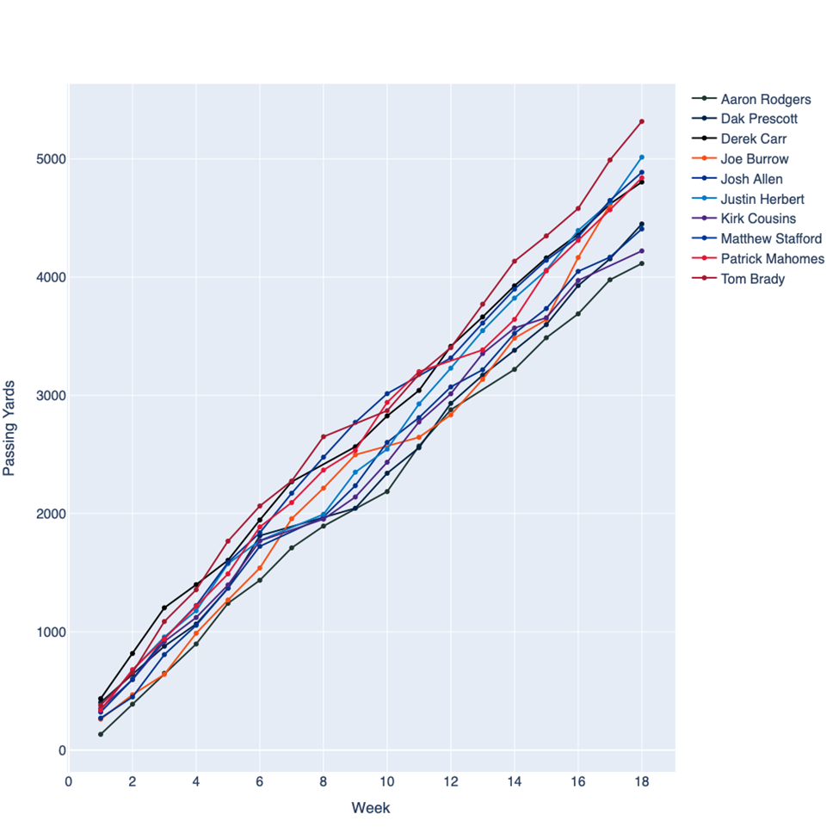

This graph shows the passing yardage being accumulated per week, with the top passing yardage quarterbacks were Tom Brady, Justin Herbert, Matthew Stafford, Patrick Mahomes, and Derek Carr. Next chart will do the same but showing the passing touchdowns per week.

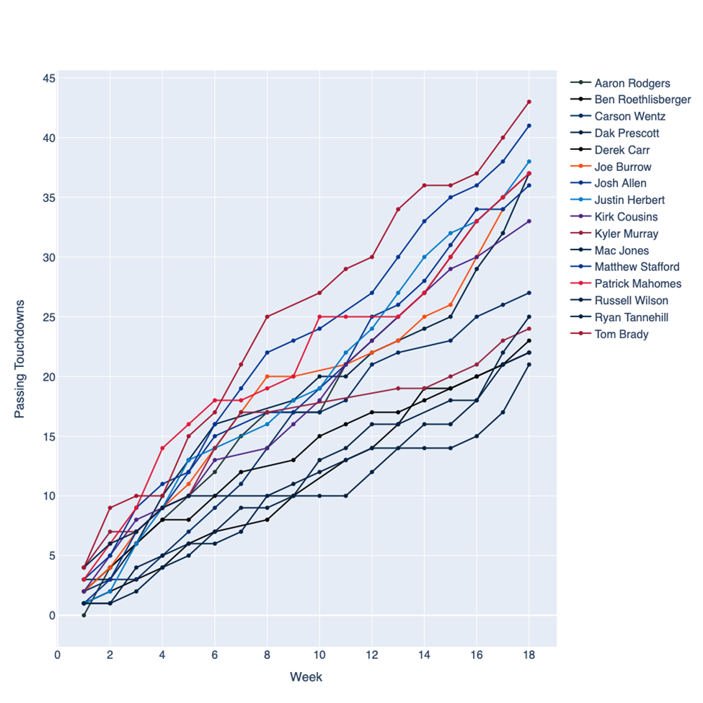

The chart filters to only QB’s that passed for over 20 touchdowns for the season. You can see that the top pass yardage QB’s are also at the top of this graph.

NOTE: Tom Brady (the best quarterback EVER) finished at the top of both graphs. One could say that we can statistically proof that he is the best.

Now we are going to shift gears to running backs and the running game. This next graph will show the production of the running backs for the 2021 season.

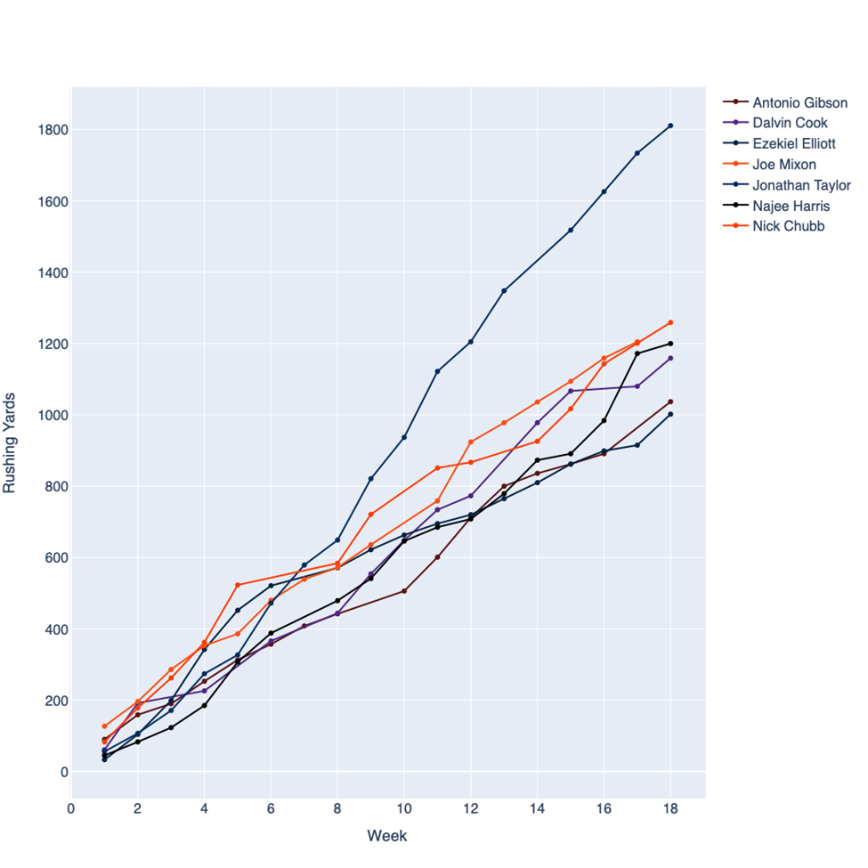

This graph was filtered to the running back’s with more than 1000 yards rushing. Jonathan Taylor of the Indianapolis Colts took the top honors with 1811 yards rushing. Next graph will show the rushing touchdown production per week from the premier running backs. We filtered to the running backs with more than eight rushing touchdowns.

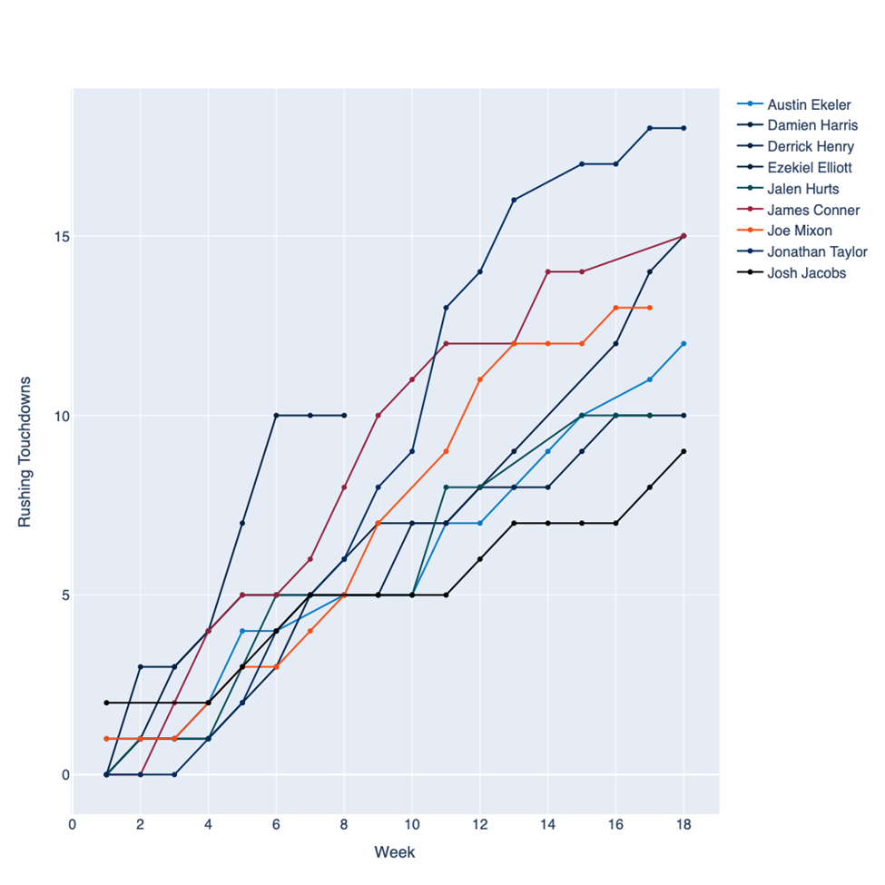

Jonathan Taylor took top honors again with 18 rushing touchdowns for 2021. Interesting facts from this chart. Derrick Henry from the Tennessee Titans was projected to have a monster season until he broke a bone in his foot in week 8 missing the rest of the regular season. Jalen Hurts of the Philadelphia Eagles, but he is not a running back, he is the quarterback of his team. This graph didn’t discriminate against his stats being shown because we didn’t use positions to aggregate the data but rushing TD’s.

Every NFL team needs a good running back. Seeing as that is, the running back is heavily relied upon, and in return, they experience the biggest physical pounding.

Defensive lineman, sometimes a hundred pounds heavier, break through the line many-a-time to bury a running back, one of the smaller positions in football (save for the kickers and punters).

So, it's no mystery why running backs, even the great ones, don't last in the league as long as other positions.

Consider the fact a few of the best quarterbacks of all-time, Dan Marino, Joe Montana, and John Elway, played a combine 48 years in the league, while great running backs such as Jim Brown, Barry Sanders, and Earl Campbell, only played a total of 27 seasons.

One of the questions we wanted to answer is the decline of the running back position. Next, we will show a graph of the 2009 season of the NFL.

Again, we filtered to the running backs who had more than 1,000 yards rushing for the 2009 season. That year, the league had 15 running backs with over 1,000 yards rushing compared to only 7 in 2021.

# Conclusions:

Teams are now using a trend that baseball started shown in the movie Moneyball. In baseball, Rigorous statistical analysis had demonstrated that on-base percentage and slugging percentage are better indicators of offensive success, and the Oakland A's became convinced that these qualities were cheaper to obtain on the open market than more historically valued qualities such as running speed and defense. To replace a player with the caliber of Jason Giambi, they brought in three cheaper option players that combined had the same on-base percentage and slugging percentage as Jason Giambi had. A running back by committee is a strategy employed by football teams in which more than one running back shares a relatively similar percentage of carries. Many teams in the NFL employ more than one running back who usually have different strengths and weaknesses. Ultimately, showing that having two-three running backs that can collectively rush for over 1,000 yards is the same as having one running back that can do the same.

Although it seemed as though in football to pass the ball more you would have to run the ball less our analysis showed us that while passing did increase over the years it did not negatively impact the number of running plays an individual team ran. This could be because offense is booming and as fast as ever meaning teams could be running more total plays. We also saw that elite running back can still be elite and have a heavy workload. Some of the biggest and best names at the QB position are averaging around 40 passes per game.